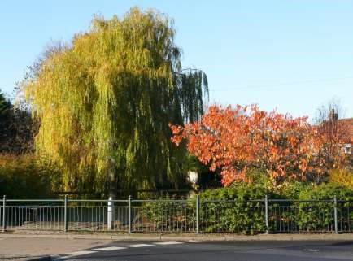

The Newsletter for Middleton on the Wolds

Issue No 20

October 2020

NEXT COPY DATE
14th October

Please send in your contributions to middletonflyer@yahoo.com by the end of the copy day. If I don’t acknowledge them please get in touch to make sure they have arrived.
Geoff’s articles on the history of Middleton are proving to be fascinating and probably even more so for those who have lived here most of their lives. If you have any extra information that you would like to share with Geoff, even if it is just memories that have been passed down through your family, you can contact him through me. He will be delighted to hear from you.
I am particularly intrigued to know where the original Victorian schoolroom was situated - see Local History on page 6.
Lyn
4 The Paddocks 219500

If you have any ideas, comments or complaints (especially complaints) you want to share then send an email to middletonflyer@yahoo.com.
Remember, we can’t respond unless we receive your message.

editorial
We're away in the camper van as I write this so I haven't got too much to report this month.
There's been some good weather at last and the (much reduced ) harvest is in. We can all now look forward to the annual glut of pheasant road kill on Beverley Road. The county council is making a good job of resurfacing the pavements on Station Road - they may even have finished
by the time you read this. I'm sure everyone is pleased to see work that improves life in the village. However, I can't leave this topic without mentioning the driver who moved a bollard so they could park half on, half off the pavement. I mean... really??!!

As always, happy to discuss this and anything else so please get in touch.

Finally, I got caught speeding on the way back from Driffield last week. I was only doing 65 so they let me off because I'd only broken the law in a limited and specific way.
You couldn't make it up, could you?

Cheers, Mike
ADVERTISING COSTS for the Messenger
Rates Month Year

Whole Page £25 £150

1/2 Page £15 £100

1/3 Page £10 £60
Full colour - Print run 500 copies
Contact: Tina 01377 217242, middletonflyer@yahoo.com
At the time of going to print there have already been at least 5 mini coffee mornings (or afternoons) in the village taking advantage of the good weather. These have raised between £45 and £60 each. There have been some donations too and the competition to guess the number of sprinkles on the “Colin the Caterpillar” cake in the Post Office is going well.
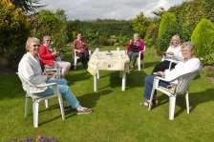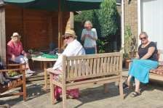

If you are still to hold your coffee and cake get-together please:

keep the number small along with the government guidelines and set the chairs at the required social distance

You can take your proceeds to Hazel Kazer, Lyn Dennis or the Post Office

There is a collection box in the Post Office for donations from anyone who would like to support this amazing and very necessary charity

A big thank you to all who have already donated

QUIZ PAGE
- Who wrote the novel Black Beauty, first published in 1877?
- What is the name of the Israeli Secret Service?
- What Year was Concords Last Flight?
- Name the Shampoo which consists of Two Parts of the Body?
- What was Colonel Tom Parker famous for?
- Which British Monarch was Prince of Orange?
- What sign of the zodiac would you be if you were born on 18th October?
- What football club is the oldest in London?
- Which Scottish River supplies over 90% of the water used in Whisky manufacture?
- On the London Underground tube map, what colour is the Bakerloo line?
All answers on page 14 Quiz set by Rowland Wooldridge
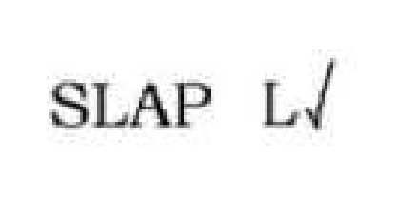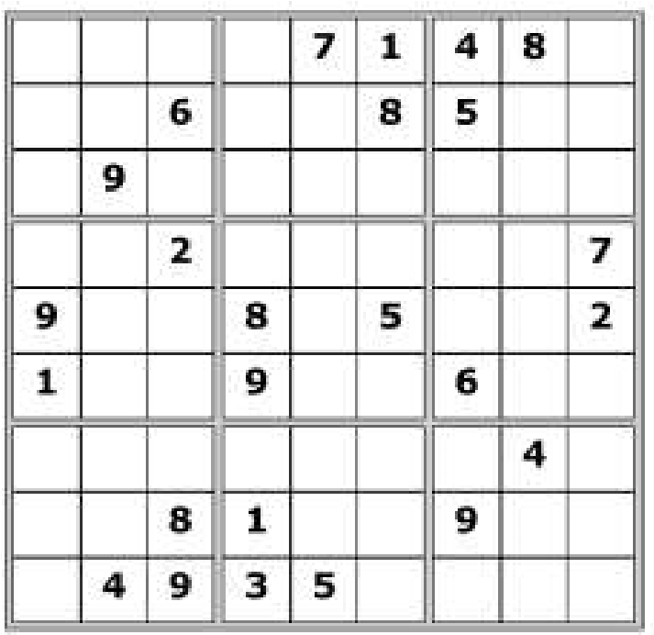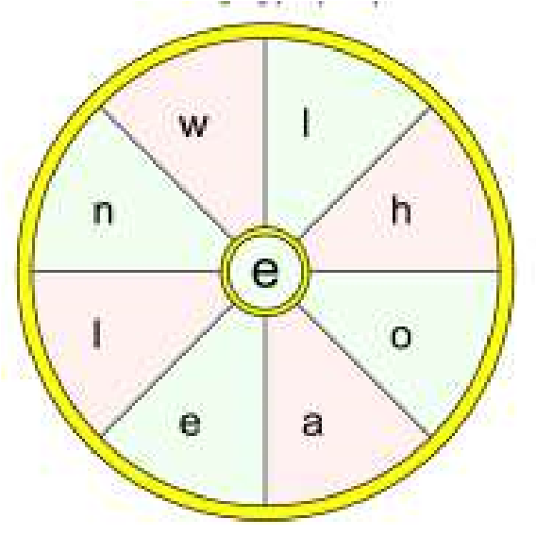

SAYINGS DINGBATS

SUDOKU

All answers on page
16

WORD WHEEL

This Summer themed word wheel is
made from a 9 letter seasonal themed
word. Try and find that word, then
make as many words of any length as
you can from these letters. You can
only use each letter once, and each
word must include the letter

E
.

LOCAL HISTORY

SCHOOLDAYS
In the early days of the twentieth century the tenant of a local farm appeared in court and stated that his boy who was over 12 years old was kept away from school to help with the harvesting because it saved him £1 in wages which he would have to pay a man to do the job. He was critical of the authorities in the timing of the school closure and added that the lad was much better off working with him than at school “Drawing donkeys”, if he had to remain at school he would then be “Ower big and awkward” and he could make “Nowt of him.” The chairman of the court reminded him of the law but the defendant replied defiantly saying “Its a funny law and the man that made it wants hanging.” He was fined thirteen shillings and left the court muttering.
This somewhat humorous case perfectly illustrates the conflict between the legal requirement enacted in 1880 for compulsory education and the economic needs of the parents who had hitherto relied on their children’s contribution to the family income.
These major changes started in 1870 when the reluctant government responded to various pressure groups and the growing fear that education of the masses was falling behind that of other countries and in particular the new German Empire led by Prussia a state renowned for its education system. Before that schooling in Middleton appears patchy but a private establishment was mentioned by the rector Christopher Brearey during Archbishop Drummond’s visit 1n 1764. The first discoverable schoolmaster was John Irwin whose name and profession appear in the parish register when his daughter Ann was christened on Christmas Day 1808. In 1812 Henry Strickland, that stern critic of public houses, was guardedly sympathetic about the deficiency of education among the lower classes, many being unable to read and still more to write or keep accounts making them unfit for many situations for which their natural abilities might otherwise qualify them and leaving them an easy prey to numerous temptations.
In 1865 a parochial school for 50 boys and girls was mentioned together with a Sunday school and night schools in the winter the latter not being
very successful. A house on Front Street is said to have been used for teaching purposes and slates have been found stored away upstairs. In 1855 the” Hull Packet” newspaper referred to an interesting lecture in the school room by Dr Sandwith of Beverley entitled “Knowledge is
Power” about the appliance of science to
agriculture before a numerous and highly delighted audience.
The various directories and census returns from 1822 to 1891 list a variety of male and female teachers. Nothing much is known about their fitness to teach and they may have had other jobs at the same time. Prominent among these were Matthew and Mary Lamplough, James Lotherington who was also post master and parish clerk together with his wife Sarah and Emily Jane Lotherington who was described as being proprietor of the Ladies’ Seminary and a music teacher. Ann Crowe had also ran a ladies’ boarding school and was on the committee of the new school in the 1870s.
Any new system was faced with the clash between those who wanted a religious based system beset by denominational rivalries and those favouring a more secular approach. To add to this problem some political leaders remained ambivalent about any government interference in general education fearing it would only create dissatisfaction in the bulk of the population who would then expect something better than the mundane jobs which they had hitherto performed. It was therefore against this background that the 1870 Forster Education Act came into existence the repercussions of which will be the subject of the next article.
Geoff Wisher

The wolds METHODIST CHURCH bainton
Services at the Chapel will be held on some Sundays in October. Please contact a church member for more details

Local contact: Jane Gray tel 07870 562455

A note from your vicar

October – The season of … Apples and True Love
As the days begin to draw in many of our summer migrant birds have now left us, our house martin families have checked out of their mud homes in the eves of the Rectory (we will have to wait another year till, hopefully, they will return and treat us to their acrobatics once more – but I will not miss the mucky paths and window beneath their nests!) The hedges are full of red shining berries which the black birds are especially partial too. And the damson tree is attracting many Red Admiral butterflies and wasps, and I know that those of you with apple trees in your garden are having a bumper crop this year.
The 28th of October is the Feast Day of St Simon and St Jude and this day was once held as a date in which you could catch an early glimpse of your future love. As it is autumn what better item to use than an apple. The skin had to be pared in one continuous piece. When you had removed it from the fruit it would then be thrown over the left shoulder, where it would form the initial of the beloved’s first name. Before casting the apple skin this rhyme should be recited three times:
St. Simon and St Jude, on you I intrude by this paring I hold to discover,
without any delay, please tell me this day the first letter of him, my true lover.

How successful this proved to be I do not know, however, I do have my doubts as St Jude is also regarded as the Patron Saint of hopeless cases!

With true love and apples in mind, here is a recipe for ‘Matrimony Cake’ taken from ‘The Farmhouse Kitchen’ by Mary Norwak. I hope you are all able to enjoy the many golden delights of this beautiful season.

Jane

St Andrew’S church
October Services

Sunday 4th October No service. Please visit other churches
Sunday 4th. October. Joint Harvest Festival at Bainton with North Dalton & Middleton.10.30.a.m.Revd Jane Anderson. All welcome
Sunday 11th October. Morning Prayers at 10.30.a.m.Holy Baptism at 11.30.a.m. Rev’d Jane Anderson
Sunday 18th October. Morning Prayers at 10.30.a.m.Rev’d Canon Kate Goulder Sunday 25th October. Morning Prayers at 10.30.a.m.Rev,d Ruth Newton.

Matrimony Cake
Ingredients:
225g or 8oz Shortcrust Pastry
4 Tablespoons brown bread crumbs
4 Large Apples
50g or 2oz mixed raisins and currents
- teaspoon mixed spice (or to taste)
Juice of 1 lemon
- Tablespoons sugar
2 Tablespoons golden syrup 1 large slice of lemon.
Milk for brushing.

Method:
Heat oven to 350 F, 180 C, Gas 4
Grease and line an 8 inch flan ring or pie dish with half the pastry.
Put breadcrumbs on the bottom of the pastry case.
Peel & core the apples and cut into rings.
Put apple rings in pastry case.
Cover the apple rings with the raisins and currents, mixed spice, juice of 1 lemon,
2 tablespoons of sugar (or to your taste) and 2 tablespoons of golden syrup.
Add the 1 slice of lemon to the top of all the filling ingredients.
Cover with remaining pastry.
Brush with milk and bake for 45 minutes – until golden brown.

Local Birds & wildlife
Well, now it is officially Autumn and there are plenty of bright rosehips and juicy elderberries and hawthorn berries ready for the birds for when the weather gets colder. The wood pigeons, as ever, ignore the passing seasons and just carry on nesting and raising young regardless. Hazel has just seen some newly fledged chicks, and there seems to be nest-building going on in the Russian vine on the embankment at the end of our garden.
Hazel also reported a big flock of starlings poking about on the school playing fields (just before the children returned) “probably looking for emerging daddylonglegs” which does remind us that it is Autumn.
Ian saw an interesting encounter recently: “ Walking on Warter Road in early September near to Grange Farm I saw a group of rooks acting in a most unparliamentary way. A chance to try out binocs post eye-op.
There was a buzzard and I assumed it was being mobbed but upon watching closely the fight was the other way round. Every time the rooks sank back toward the roost the buzzard attacked, talons out and the group had to reform to see it off. It must have been too late in the year for there to be young in the nest – although plump young rooks were the original ‘four and twenty blackbirds’ - perhaps a juvenile was chancing it or showing off. Do you remember a young Hugh Fearnley-Whittingstall climbing to collect young rooks and cooking them?”
Earlier in the year Alice decided to follow the advice to make her garden more frog-friendly. She sank several old buckets in the ground, made ramps of stone and soil so the frogs could easily get in and out (and marauding hedgehogs would not fall in and drown) and filled them with water. She was amazed how quickly the amiable amphibians moved in, and through the summer any walks up the garden had a background soundtrack of plopping frogs gratefully returning home.
As I write this we are in the middle of a mini-Indian Summer, and Andy and Liz have told me that a few evenings ago they were excited to see two dragonflies on South Street, having lived here for ten years without seeing any. Then a couple of days later “We saw a solitary one making it’s way up Station Road. Good to know that there must be a suitable habitat for these wonderful insects in the village. Well done to all those people who maintain a wildlife pond.” Alice – are your buckets harbouring other inhabitants?
If you see anything interesting in your garden – or anywhere around Middleton – please let me know at lavenderbarbara97@gmail.com or 0777 192 7868. Also it’s lovely to see your photos – we include them if we can!
Barbara

Middleton book group

September Meeting
We were very lucky with the weather again for this meeting, and enjoyed sitting out in Lyn’s lovely garden. We combined the meeting with the Macmillan Coffee Morning appeal
(though being free spirits, we held ours in the afternoon).
We ended up with a choice of three books this time, as there were issues with availability of the ones I originally chose, but between us we had read enough to discuss two of them: The Wind on the Moon, by Eric Linklater proved too elusive!

Photographing Fairies, by Steve Szilagyi, was a disappointment, particularly to me as I had read it several years ago and on re-reading it prior to our meeting realised that it wasn’t the book I remembered. It is a novel published in 1995, but set when Conan Doyle’s promotion of fairy photos in 1917 was causing a stir. While some of the plot was quite intriguing – the main character being a photographer who is persuaded to try and replicate different “genuine” photos - the characters seemed less believable on my second reading; the dialogue between them incongruously American in places. No-one defended it!

The hastily-added Diary of a Nobody, by George & Weedon Grossmith (originally serialised in Punch magazine in 1888/9) was enjoyed much more and seemed (curiously) more modern. One person who didn’t really enjoy it felt the main character was a bit too much of a cross between Basil Fawlty and Hyacinth Bucket, but most of us enjoyed his innocence when recounting events and found the book light and easy to read. It was written in more accessible English than we tend to expect from that era (Charles Dickens, I am talking of you) and with plenty of humour.
Barbara

Next books for discussion:
“Where the Crawdads Sing” by Delia Owens “The Sewing Machine” by Natalie Fergie

To find out more about the Book Group please contact Lyn on 219500 or lyndennis456@gmail.com

Village hall news
The Village Hall is back in full swing with Pilates, Line Dancing and Movers weekly. The hall has also been used by the local branch of National Women’s Register (NWR). Their meetings are usually held in members’ homes but, of course this can’t happen at the moment so the Village Hall was an ideal venue to space out the 13 members who attended.
If you are using the Village Hall please comply with the signage showing the government instructions regarding social distancing, regular hand washing and hand gelling. Entry for people attending classes will be via the side fire doors and exit via the front doors to avoid a bottleneck in the entrance hall near the toilets. In the toilets, only one person at a time is to be in the ladies and one in the gents but the disabled toilet will also be in use. The Village Hall is fully equipped with the safety equipment, sanitisers and signage required to be COVID-19 compliant.
If you would like to hire the hall for a private function please get in touch with me on 219500 or preferably lyndennis456@gmail.com
Our committee meetings will be on the first Tuesday in the month in future - 2.30pm in the VH. New members are very welcome.
Lyn Dennis
The Village Hall Committee

For those of you who have not heard of NWR, and I expect that is the majority, I will explain. There are hundreds of groups around the country and the Beverley & District
Group meet fortnightly to hold discussions and research
various topics. We also, in “non-covid” times, have various social gettogethers including a book group, topical news discussion group, lunch club, supper club and a wine-tasting group. I have been a member for about 40 years. If you fancy giving it a try please get in touch. Lyn
Reading room news
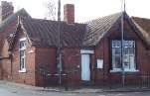
The Reading Rooms is now open for business. Please contact Kath Bentley for bookings - 217456.
We need committee members, particularly a secretary. If anyone would like to help run this important village amenity you would be more than welcome to join us.
Mike Kelly mk@motwparishcouncil.co.uk

Parish council

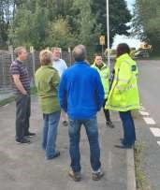
Community Plan/ Traffic Issues
Members of the Parish Council and public recently met with our County Councillor and representatives from East Riding Rural Council to discuss the many traffic issues within and around the village. They were provided with a written report of the issues as recorded since 2015 and a copy of our Community Plan Action Plan highlighting both the issues and our decision to prioritise traffic as our number one community concern. During a walkabout they were able to witness the heavy traffic down Front Street along with the size, speed and noise it makes. In addition issues of dangerous parking along Station Road, Pickering Park, Greenfield Road and speed issues on Beverley Road and Chapel Lane/ South Street were also examined.
A whole range of possible actions were discussed including speed humps, better signage, Zebra crossings and the hours of operation and traffic conditions In the village. ERYC will follow up the visit with a traffic census to be held shortly and then meet again with the Parish Council to decide on the actions that can be taken. Watch this space for further updates!
In between times please continue to report any further incidents to any member of the Parish Council. Please also help by continuing to be considerate when driving and parking within the village.

The playground Survey
The survey is being relaunched in October and all residents are invited and encouraged to complete the form. All your families views are important and it would be great if your household would complete it together so we get as many
age diverse views as possible. Parish Council volunteers will call and collect your completed surveys on SATURDAY 24th October between 10-3pm. Thank you.

Considerate parking on corners in the village
A reminder that parking near corners can be dangerous and is illegal!
It has been highlighted that inconsiderate parking particularly on the corner of Greenfield Lane and Pickering Park is making life difficult for residents living there. It also makes it difficult for Waste Disposal vans to get access and would be problematic for any emergency vehicles/ fire engines.
Please consider this when parking and also advise any visiting tradespeople/ commercial vans calling at your property to park responsibly, even if this means parking a little further away.
Nick Jones
Parish Councillor

The evening before Diane’s (my wife) landmark birthday, our 14-year-old daughter Victoria asked me to come to the computer as she had a problem. The PC was logged on to a web site that offered people the chance to have a star named after them. Victoria wanted to ‘borrow’ my Visa card so she could buy one for her mother. Typically this was the day before my wife’s birthday and at a time when all the shops were closed. I therefore frowned at my daughter’s lack of foresight and (noticing the price of a star) said that it would be better if she wrote a poem for her mother to make it more personal. While I downloaded suitable artwork background for it to be printed on Victoria wrote the poem that follows and gave it to her mother.
Diane wept.
Geoff Cox
Naming a Star.
As this day is so special
And so important through and through I’d thought I’d name a star after you.
Although this idea was laughed at
And thought impossible and random to do
I still wanted a star to put into history for you.
Yet I did not order it from a catalogue
Or some online shopping site
For one single star did not seem enough
To express all my love and gratitude.
So if you ever need to know my love
If that could ever be true
All you need to do is look at the stars
For they all shine out my love to you
All my love to you mum
Victoria xxx
Middleton is looking a bit unloved........
Have you noticed the dreadful state that the kerbs in the village are in. Judging by the amount of grit and plants that have accumulated at the roadside it would seem that we haven’t had a visit by the Council road sweepers in a long time.
On a tour of the village on Wednesday evening with one of our ward councillors I pointed out the results of insufficient and infrequent cleaning of our roadside kerbs. He was honest in saying that there was no money for additional cleaning.
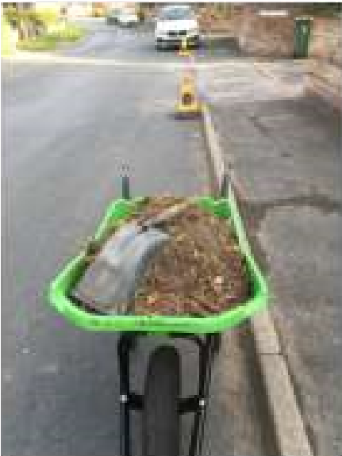
With this thought in mind Liz and I set ourselves the challenge of cleaning the kerbs on Station Road – we had no idea just how much grit, soil and weeds had accumulated. From Greenfield Lane up to Warter Road we filled 4 and half wheelbarrows – see the photo. Additionally we cleared the gulley alongside the pavement by the village green and telephone box.
On our walks around the village there are plenty of other places where the kerbs are just as bad – We would like to encourage you to do your part to smarten up the village by looking at the kerb outside your property to see if they need the same attention.
Andrew Naylor
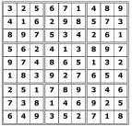
Quiz answers

Dingbats:

3
wise monkeys

Top secret

See you in the morning

Search high and low

Set in motion

Word wheel:

Halloween

1

Anna Sewell

2

Mossad

3

26
th

November 2006

4

Head and Shoulders

5

Being Elvis's Manager

6

William 111

7

Libra

8

Fulham

9

Spey

10

Brown

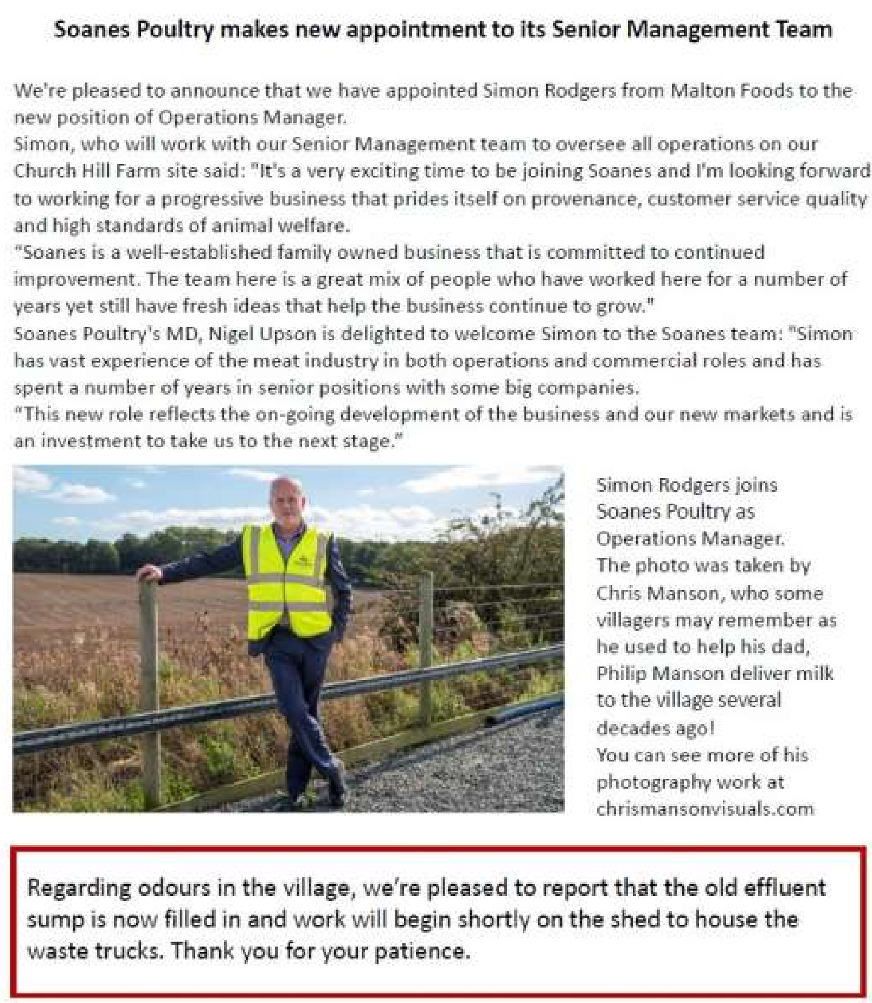
Advertising Feature

Advertisement
Advertising Feature
Regular group activities
Weekly Groups
Monday Pilates 6.00-7.00pm Village Hall Wednesday Line Dancing 7.30-9.00pm Village Hall
Thursday Middleton Movers 2.00-3.30pm Village Hall

October
- Parish Council 7.00pm Zoom
- Village Hall Committee 7.30pm Village Hall
13 Book Group 2.00pm Ring 219500 for venue
15 Country Women’s 7.30pm Village Hall 18 Middleton Womblers 10.00am Lime View

LOCAL CONTACTS Bell Ringing Chris Atkin |  | 217285
Book Group/Middleton Movers | Lyn Dennis | 219500
Bowls Club | Rob Bradley | 217435
Country Women’s Association | Christine Johnson | 217374
First Responders | Chris Brent | 219469
Line Dancing | Pat Pottage | 217516
Methodist Chapel | Jane Gray | 07870 562455
Middleton Messenger | Mike Kelly | 07713 620912
 | Lyn Dennis | 219500
 | Tina Walker | 217242
Middleton Womblers | Andrew Naylor | 219072
Parish Clerk | Sandra Morrison | 01262 470496
Pilates | Ian Stephenson | 07973 755717
Reading Rooms | Kath Bentley | 217456
Recreation Club | Dave Newlove | 07901 833784
St Andrew’s Church | Rev Jane Anderson | 219471
St Andrew’s Church Warden | Roger Lowe | 217656
Table Tennis | Louise Newlove | 217801
Village Hall | Lyn Dennis | 219500
Village History | Geoff Wisher | 217517

